Step 1: Installation of java
Open google > Insert download java jdk and search > Click on “JDK download link in Java SE - Downloads | Oracle Technology Network | Oracle ...” > System redirected on “Java SE Development Kit 8 Downloads” > According to system configuration download java eg. We downloaded “Windows x64.exe” > Execute the exe file and install java > after installing java > Go to Run > and type cmd > system redirected on Command prompt > write “java –version” and click on enter button > installed java version should be displayed.
Step 2: Configuration of java
Go to C drive and open the path upto bin “C:\Program Files\Java\jdk1.8.0_291” and copy it > Go to “My PC OR My Computer” > click on “Right click” button of mouse > Click on Properties > Click on Advance System setting > Click on “Environment Variables” > System redirected on “Environment Variables” popup > click on “New” of User variable” > New user variable popup should be open > Enter “JAVA_HOME” in Variable name field > Enter copied path “C:\Program Files\Java\jdk1.8.0_291” in to Variable value field > Go to “System Variable” section of “Environment Variables” popup > Select Path in available list and click on Edit button > Go to last of variable value > enter semicolon {;} and paste copied path C:\Program Files\Java\jdk1.8.0_291\bin” > click on “Ok” button > after configuring java > Go to Run > and type cmd > system redirected on Command prompt > write “javac” and click on enter button > system should be displayed the output.
Step 3: Installation of Maven
Open google > Insert download Maven for windows and search > Click on “Download Apache Maven of Maven – Download Apache Maven - The Apache Software ...” > System redirected on “https://maven.apache.org/download.cgi?Preferred=ftp://mirror.reverse.net/pub/apache/” > Downloaded “Binary zip archive” link file > Create new folder with Maven name > Cut and Paste the downloaded file > Extract it.
Step 4: Configuration of Maven
After extracting go up to bin folder page and copy the path “D:\Automation\Maven\apache-maven-3.8.1-bin\apache-maven-3.8.1 “ > Go to “My PC OR My Computer” > click on “Right click” button of mouse > Click on Properties > Click on Advance System setting > Click on “Environment Variables” > System redirected on “Environment Variables” popup > click on “New” of User variable” > New user variable popup should be open > Enter “MAVEN_HOME” in Variable name field > Enter copied path “D:\Automation\Maven\apache-maven-3.8.1-bin\apache-maven-3.8.1” in to Variable value field > Go to “System Variable” section of “Environment Variables” popup > Select Path in available list and click on Edit button > Go to last of variable value > enter semicolon {;} and paste copied path D:\Automation\Maven\apache-maven-3.8.1-bin\apache-maven-3.8.1\bin” > click on “Ok” button > after configuring Maven > Go to Run > and type cmd > system redirected on Command prompt > write “mvn” and click on enter button > system should be displayed the build failure message.
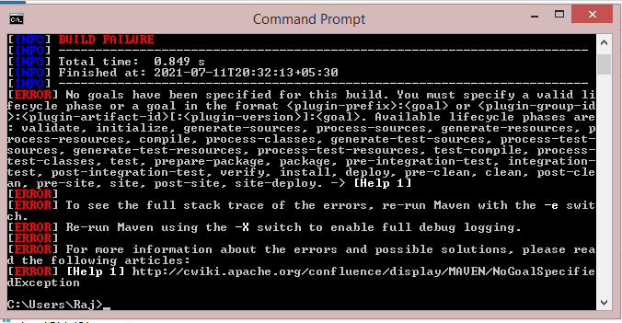

Step 5: Installation of Git
Open google > Insert download git for windows and search > Click on “Download for windows” from url https://git-scm.com/downloads > Create new folder with GitHub name > Cut and Paste the downloaded file > Extract it.
Step 6: Configuration of Git
After executing exe file > Go to Program files > go up to bin folder page of Git and copy the path “C:\Program Files\Git“ > Go to “My PC OR My Computer” > click on “Right click” button of mouse > Click on Properties > Click on Advance System setting > Click on “Environment Variables” > System redirected on “Environment Variables” popup > Go to “System Variable” section of “Environment Variables” popup > Select Path in available list and click on Edit button > Go to end of variable value > enter semicolon {;} and paste copied path “C:\Program Files\Git\bin” > click on “Ok” button > after configuring Git > Go to Run > and type cmd > system redirected on Command prompt > write “git” and click on enter button > system should be displayed the output.
Note: Git is a version control tool, it’s use for pull, push the code and security check. It’s linux.
Git hub is a code repository.

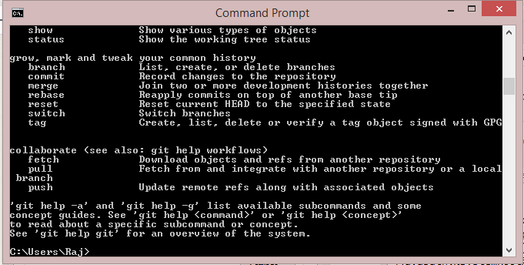
Step 7: Eclipse installation
Open google > Insert download eclipse URL “https://www.eclipse.org › downloads” > click on Download Packages link > Download eclipse for windows from “Eclipse IDE for Enterprise Java and Web Developers “ > Create new folder with eclipse name > Cut and Paste the downloaded file > Extract it
Step 8: Create account in Github with require detail.
Difference between Git v/s Github:


Step 9: SSH key generation at Github:
Login in to Github > Go to Setting under my profile > Click on SSH and GPG key > Open “generating SSH keys” link under SSH Keys in new tab > Open “Git Bash Here” window > Click on link “Generating a new SSH key and adding it to the ssh-agent” > Copy the command "ssh-keygen -t ed25519 -C "your_email@example.com" from "Generating a new SSH key" section and paste it in to "Bit Bash Here" window { ssh-keygen -t ed25519 -C “vivekcjs@gmail.com”}> Output: This creates a new ssh key, using the provided email as a label. {Generating public/private ed25519 key pair.} with message “Enter file in which to save the key (/c/Users/Raj/.ssh/id_ed25519):
:” > Don’t enter any value and click on enter button > System throw message for “Overwrite (y/n)?” > Don’t enter any value and click on enter button > Now copy the command "eval "$(ssh-agent -s)"" from "Adding your SSH key to the ssh-agent section" and paste it > Output: Agent pid 756 > Now copy the command "ssh-add ~/.ssh/id_ed25519" from "Adding your SSH key to the ssh-agent section" and paste it > Output: Identity added: /c/Users/Raj/.ssh/id_ed25519 (vivekcjs@gmail.com) > Open link “"Adding a new SSH key to your GitHub account." from "Adding your SSH key to the ssh-agent section" > Now copy the command "clip < ~/.ssh/id_ed25519.pub" from "Adding a new SSH key to your GitHub account" and paste it and hit enter button > Now click on New SSH key button and paste > Output: Key generated > click on Add SSH key button >

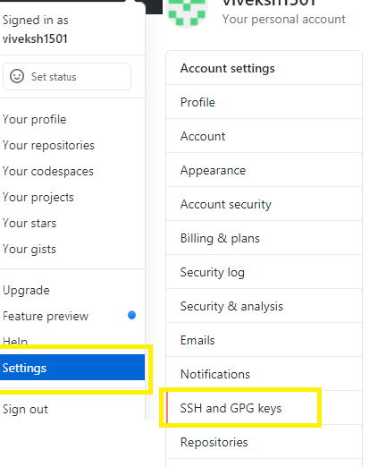
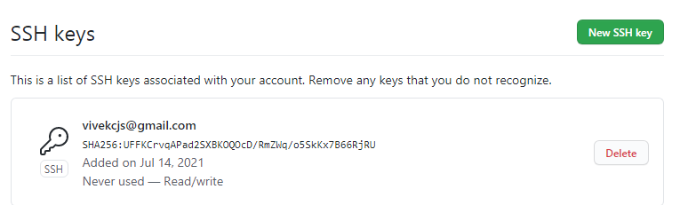
Step 10: GPG key generation at Github:
Login in to Github > Go to Setting under my profile > Click on SSH and GPG key > Click on “New GPG key ” button > Open “Git Bash Here” window > Enter command “gpg --full-generate-key” and hit enter > Output: System ask for option selection > without any selection hit enter button, system automatically take default value “RSA and RSA” > Output: System ask for key size “RSA keys may be between 1024 and 4096 bits long. What keysize do you want? (3072)” > Hit enter with suggested value or 4096 > Output: System ask for key validity > System ask for confirmation > Enter “y” and hit enter > enter command “gpg --default-new-key-algo rsa3072 --gen-key” and hit enter > Output: System ask for email > enter email address > Output: System ask for comment > enter comment “GPG key check” > > Output: System ask for confirmation or change > Enter “O” for okay > System ask for password “Passpharse” > enter password and click on “Ok” button > Ask for re-enter the password > now enter the command “gpg --list-secret-keys --keyid-format=long” and hit enter > Output: System generated the GPG key > Provide armure to generated key through command “gpg --armor --export” and hit enter > System generated the GPG key > Copy the generated key > Go to Add GPG page and after pasting save it.
GPG key are important in Github because it allow to others to know that you made a change.
